Voices Beyond Walls (VBW)
678-453-4082

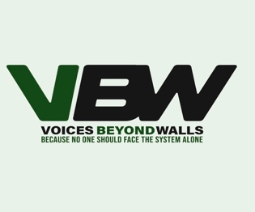

Intake Form for Advocacy Services Request

Program name: Volunteer Peer Support and Advocacy
Facility: ____________________
Date submitted: ____________________

---

1. Detainee Information

• Full name
• Detainee ID number
• Housing unit and cell
• Date of birth
• Preferred name
• Preferred pronouns
• Primary language

---

2. Contact and Background

• Booking date
• Arresting agency or case number
• Assigned attorney name and contact
• Probation or parole officer name and contact
• Court date(s) and next hearing date

---

3. Services Requested

Select all that apply

• Volunteer peer support sessions
• Family outreach at my request
• Administrative liaison with probation or parole officials
• Administrative liaison with court clerks or court staff
• Other support or resource navigation — Describe: ____________________

Brief description of request or issue
Provide a short summary of what you want help with and any immediate needs.

---

4. Family Outreach Consent

• Do you authorize outreach to family or emergency contacts• Yes ☐ No ☐

• If yes, list names and relationship

Name: ____________________ Relationship: ____________________ Phone: ____________________
Name: ____________________ Relationship: ____________________ Phone: ____________________

Information to share with family

• Check items you permit us to share• Case status updates ☐
• Health or wellbeing updates ☐
• Release or reentry planning information ☐
• Other: ____________________

---

5. Attorney Contact and Privilege Acknowledgment

• Do you want our team to contact your attorney or public defender on your behalf• Yes ☐ No ☐

• Acknowledgment• I understand that volunteers will not provide legal advice and that contacting an attorney may implicate client–attorney privilege. I authorize non-legal administrative outreach only unless separate legal clearance is obtained.
• Initials: _______

6. Accessibility and Special Needs

• Do you have any medical, mental health, or accessibility needs we should know about• Yes ☐ No ☐

• If yes, describe---

7. Emergency Contact

• Name
• Relationship
• Phone number
• Alternate phone or email

---

8. Consent and Release

• Consent for services• I consent to receive volunteer peer support and non-privileged advocacy services from the program described above. I understand the limits of the services, including that volunteers do not provide legal advice and that certain activities may require County or legal review.
• Detainee signature: ____________________ Date: ___________

• Consent for limited information sharing• I authorize the program to share non-privileged information with facility staff and designated external agencies as needed to provide services and referrals.
• Detainee signature: ____________________ Date: ___________

Privacy Notice

We will keep your information confidential to the extent permitted by facility rules and law. Information shared during sessions is non-privileged and will be documented in brief activity logs. Any disclosure required by law or facility policy will be reported to appropriate staff. Requests involving attorney contact or privileged matters will be paused pending legal review.

